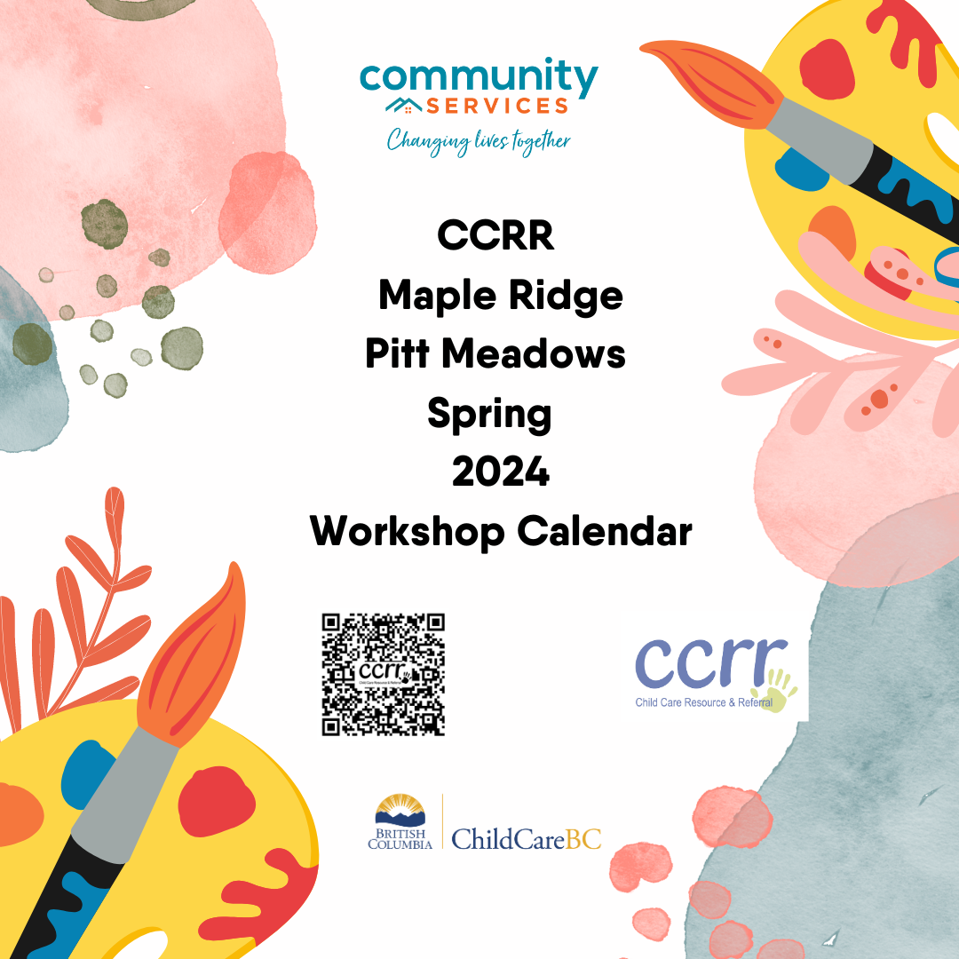

**Funded by the Province of BC**

[**www.comservice.bc.ca**](http://www.comservice.bc.ca)

<https://www2.gov.bc.ca/gov/content/family-social-supports/caring-for-young-children>

***To register for workshops:***

<https://www.eventbrite.ca/o/child-care-resources-and-referral-38950456893>

***Please visit our website or call the office 604-467-2273 for more information***

***If you have questions, please email*** [***ccrrp@comservice.bc.ca***](mailto:ccrrp@comservice.bc.ca)

**Circle Of Security for Child Care Providers**

**Facilitator:** Anna Giacometti and Adrianna Bazijanec

**Date:** Mondays January 8th – March 4, 2024

**Time:** 6:30 – 8:00 pm

**Location:** Zoom

**Cost:** Free

**Maximum:** 20 participants

**Workshop information:** There are times when child care providers might feel lost figuring out what the children in our care need from us. This program is based on decades of research about how secure caregiver/child relationships can be supported and strengthened in their Centre. Participants will learn to understand a child's emotional world by learning to read their emotional needs. Participants will learn to support children's ability to successfully manage emotions while enhancing the children's self-esteem. Additionally, you will learn to honor your innate wisdom and desire for children to be secure.

**Certificate Provided**

**Pre-registration required**

**What? Why Me Worry? Supporting Children with Anxiety**

***Facilitator:*** *Dr. Vanessa LaPointe*

**Date:** Wednesday, February 7, 2024

**Time:** 6:30 – 8 pm

**Location:** Zoom

**Cost:** Free

**Maximum:** 55 participants

**Workshop Information:** Dr. LaPointe's passion in life is to change the conversation about how we make the world go round for all of the kids we are growing up. She wants children to grow up the best way possible. Dr. LaPointe wants parents, teachers, caregivers and other big people in a child's life to know they are a child's answer. She wants the mysteries of brain development and complexity of a child's need to feel totally conquerable so kids know you've got this. Participants of the workshop will leave with new ideas and understanding of how to walk alongside the children who may have struggles in their life.

**Pre-registration required**

**Certificate provided**

**Embracing Gender Diversity**

***Facilitators:*** Kendra Hill and Elliot Wheatcroft

**Date:** Tuesday, February 13, 2024

**Time:** 6:30 pm – 8:30 pm

**Location:** Zoom

**Cost:** Free

**Maximum**: 55 participants

**Workshop Information:** Celebrate Gender Diversity is an interactive and engaging online workshop. Elliot and Kendra use a personalized, intersectional approach to discuss the culture of gender diverse children and families. They share their compassionate perspective through story and offer scenarios, role plays and thoughtfully directed dialogue to help prepare participants to be more comfortable when engaging in social change.

**Certificate Provided**

**Pre-registration required**

**Stronger Together: Equity, Diversity and Inclusion in Child Care Conference**

***Facilitator:*** CCRR Staff

**Date:** Friday, March 8 & Saturday March 9, 2024

**Time:** Friday 5:30 pm – 9:00 pm and Saturday, 7:30 am – 3:30 pm

**Location:** Ridge Meadows College

**Cost:** Free

**Maximum**: 100 participants

**Workshop information:** This conference will focus on providing opportunities for educators to explore current best practices for include children with diverse learning needs, to create an anti-bias curriculum and how to strengthen their practices so they are providing more equitable care and safe spaces for all children and families. `Lunch and refreshments included. There will be a variety of vendors for your shopping pleasure.

**Certificate Provided**

**Pre-registration required**

**Nurtured by Nature**

***Facilitator:*** *Prab Gill*

**Date:** Thursday, March 14, 2024

**Time:** 6:30 pm – 8:30 pm

**Location:**  Zoom

**Cost:** Free

**Maximum**: 30 participants

**Workshop information:** When was the last time you played outside? Prab Gill, is an Early Childhood Education Instructor for local colleges with hands on experience providing child care as a manager and early childhood educator in the lower mainland. She will lead us through this workshop focusing on how nature nurtures the brain and the benefits of outdoor play. Prab believes children need ample opportunities for both structured and unstructured play. Participants will also go over the necessary licensing requirements for outdoor play for Child Care programs in BC while also exploring safety considerations.

**Certificate Provided**

**Pre-registration required**

**Social and Communication Skills for Children with Special Needs**

***Facilitators****:*Farrah Rahim & Andrea Rizzuto

**Date:** Wednesday,

**Time:** 6:30 pm – 8:30 pm

**Location:** Zoom

**Cost:** Free

Maximum: 45

**Workshop information:** Farrah Rahim and Andrea Rizzuto are both Speech and Language pathologist behind Playground Connections who will lead and equip educators with new knowledge and tools necessary for communication and socialization for children who have a special need. Both have years of experience working in multi-disciplinary clinics and educational settings including on the largest and most diverse school boards in the Canada giving them the exceptional experience in all areas of pediatric speech language pathology. They believe communication is a fundamental aspect of human interaction, enabling us to connect, express our needs and build relationships.

**Certificate Provided**

**Pre-registration**

**Aansaamb aen kiskayhtaamaahk Learning Together**

**Facilitators*:*** Violeta Savic and Amber McLeod

**Date** Saturday, April 13, 2024

**Time:** 9:30 am – 3:30 pm

**Location:** 22768 119th Avenue (Enter “the Club” through the back door)

**Cost:** FREE

**Workshop information****: Aansaamb aen kiskayhtaamaahk--"Learning Together"** (heritage Michif, translated by Norman Fleury), is a professional guide resource kit and workshop intended early learning and child care professionals to integrate Metis content in early years programming. Participants attending the full day workshop will be provided additional opportunities to support incorporating Metis specific teachings within the early years programming, promoting learning environments in which Metis culture is recognized and celebrated.

**Facilitator Amber McLeod** is an early childhood educator with a diploma in Infant/Toddler and Special Needs/Diverse abilities for over 30 years recently joining Metis Nation of BC as a support coordinator for all of Vancouver Island and Powell River. Her role includes assisting families to connect with funding and child care facilities and presenting cultural workshops to programs within our chartered communities and facilitating Metis Good Beginnings courses for anyone who is interested in learning more about children. Amber works and lives with her son on the Traditional unceded territory of Coast Salish peoples and Snuneymuxw First Nation and the chosen home to Mid-Island Metis Nation.

**Facilitator Violeta Savic** is a Child Care Navigation and Support Coordinator for Metis in Fraser Valley and the Lower Mainland working in the field of early childhood education for nearly 25 years. Her experience working at MNBC/Ministry of Education has been invaluable in shaping her passion for Indigenous Culture and her commitment to working with Indigenous families while working with the community. Violeta has developed a deep understanding of best practices and child care issues as she has gained extensive experience through her roles as an ECE college instructor, Child care consultant and as a supervisor in various locations. She has a grown son and enjoys spending time with family on the unceded territories of Semiahmoo, Katzie and Kwantlen First Nations (Surrey)

**Certificate Provided**

**Pre-registration required**

**Coaching Leaders Part 1**

***Facilitators:*** Krista Tkachuk and Emma Gaciu

**Date:** Wednesday, April 24, 2024

**Time:** 6:30 pm – 8:30 pm

**Location:** Cornerstone Building, 22768 119th Avenue, Maple Ridge

**Cost: Free**

**Maximum**: 25 participants

**Workshop Information:** Come join us for an informative session on navigating the world of child care with licensing officers Krista Tkachuk and Emma Gaciu. Whether you're a seasoned professional or just starting out, this event is designed to provide you with valuable insights and guidance on what is active supervision and how do I support my staff in ensuring positive supervision at all times as well learning how to take a leadership role in responding to all complaints.

**Certificate Provided**

**Pre-registration required**

**Supporting the Mental and Development of Children and Youth in a Covid 19 Prevalent World**

***Facilitator:*** Dr. Matt Carwana

**Date:** Wednesday, May 29, 2024

**Time:** 6:30 pm – 8:00 pm

**Location:** Zoom

**Cost:** Free

**Maximum:** 50

**Workshop information:** During this workshop participants will hear some of the newest research on how the Covid-19 pandemic and its associated public health measures impacted child and youth well- being. We will pay particular attention to mental health as well as developmental well-being. Dr. Carwana will also discuss some key strategies to communities and caregivers can use to support pandemic recovery in this population.

Matt Carwana (he/him) is a pediatrician at BC Children's Hospital and researcher at the UBC Human Early Learning Partnership. He is a medical lead for the BC Children's Hospital Social Pediatric program. He has a particular interest in supporting children, youth and their families adversely impacted by the social and structural determinants of health. He is the project lead for Covid -19 Indirect Consequences of National POPCORN Research Platform.

**Certificate Provided**

**Pre-registration required**

**Coaching Leaders Part 2**

***Facilitator:*** Krista Tkachuk

**Date:** Wednesday, June 13th, 2024

**Time:** 6:30 pm – 7:30 pm

**Location:** CCRR/Community Services 22768 119th Ave Maple Ridge

**Cost:** Free

**Maximum**: 25 participants

**Workshop Information:** Welcome to our event on **Coaching Leaders with Child Care Licensing**! Join us for an evening of learning with Licensing officer, Krista Tkachuk. Krista will go over Reportable Incidents; Why and how we report and the importance of reporting and she will also talk about Temporary Placements and what to consider when applying for one. This event is perfect for anyone working in child care facilities.

**Certificate Provided**

**Pre-registration Required**

**Happy Summer!**

###### Workshop Etiquette, Policies & Procedures

* Please register with the link provided if you are unable to do so please call the CCRR and we will assist you.

604-467-2273

22768 119th Ave   
Maple Ridge, BC

V2X 4L2

* Please ensure you have a device that is ZOOM compatible.
* Please arrive to all workshops approximately 5 minutes prior to the session.
* During Zoom workshops we request that participants have their camera on at all times and have a microphone available to be able to participate in the discussions.
* To receive your certificate please complete the survey with the link provided for each workshop.
* Please remember to cancel, if you are unable to attend, as we often have waiting lists of others who would like to attend if a space becomes available.
* A workshop may be cancelled or rescheduled in the event of an emergency situation or if there is insufficient enrollment to hold the session. You will be given as much notice as possible.
* For all CCRR workshops a 48-hour cancellation policy is in effect. If you need to cancel and do so with the required 48 hour required notice, the workshop fee will be refunded via a cheque in the mail.
* For the First - Aid course offered through Pacific First Aid, they have a different cancellation policy. Please remember that once you have registered there are no refunds or transfers into another class, unless written notification is received 72 hours prior to the class.

Most of all, enjoy the workshops!